NEPAL: Heavy rains and flooding
Office of the UN Resident Coordinator Situation Report No. 48
As of 22 October 2021

This report is produced by Office of the Resident Coordinator in collaboration with partners. It covers the period from 17-
22 October 2021. The next report will be issued on or around 29 October 2021.

SITUATION OVERVIEW

Unseasonal, heavy rains beginning 17 October in the West of Nepal and continuing for several days, moving east on 19 October have left a wake of deaths, missing persons, damage to roads, bridges, hydropower stations and other physical infrastructure as well as heavy agricultural losses due to flooding and landslides across the country.

Current estimates of losses vary, but assessment processes are ongoing to develop a clear picture of impacts, needs and gaps. More clarity is expected in the coming days. However, what is emerging
clearly is that the most substantial impacts are in agriculture, with heavy damages to both land and crop yields.

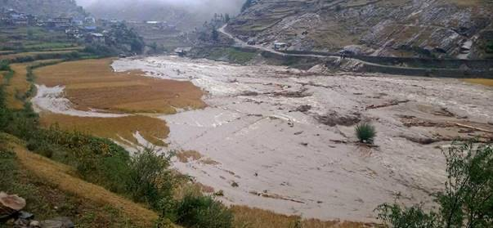Inundated paddy field in Karnali province

Current losses, combined with the existing livelihood setbacks caused by the COVID-19 pandemic could be devastating and severely impact the survival of many families in the coming months. In addition, the impact of evacuations, collective sheltering and rescue operations on COVID-19 transmission will emerge only in the coming weeks.

PROVINCIAL UPDATES

Province One
• Heavy rains beginning 19 October have led to inundation and destruction of paddy crops across the province.
• Search and rescue teams were deployed from municipal and Armed Police forces in several affected areas.
• Inaruwa electricity sub-station was submerged by flood waters and severely damaged.

Province Two
• Low lying areas are reported to be fully waterlogged; many roads have been submerged and dams damaged.
• Some government offices in Rajbiraj Municipality were inundated.
• 1,000 households were displaced by heavy rainfall in Sunsari.
• Thousands of farmers have lost their crops, with major losses in food production for this season now expected.
• Electricity temporarily cut off by heavy rains.

Lumbini
• Tens of thousands of hectares of paddy fields are reported to have been destroyed.
• Inundation in Rajapur and Geruwa has led the local government to declare relief packages for farmers.

Karnali
• Thousands of hectares of paddy fields are reported to be destroyed
• Communication services and electricity cut off by the heavy rains and snowfall.
• Micro-hydro project, water mills and local bridges have reportedly been washed away in flooding.
• Landslides have affected many parts of the province, with several people reported missing or deceased.
• Nearly 100 households located in vulnerable areas have been evacuated to safer places.

Sudurpaschim
• Several districts and palikas heavily affected with up to 3,000 households reported to be evacuated due to forecast heavy rains on 18 October.
• Newly harvested and standing crops severely damaged, with early reports estimating the potential loss of up to
25% of paddy production in some areas, as well as loss of livestock in affected areas.
• Agriculture directorate has mobilized a rapid assessment of crop, vegetable and livestock losses.
• Transportation, communication and electricity disrupted with roads blocked by landslides in seven hill districts.
• Rescue operations mobilized, including by helicopter for those trapped by flood.

United Nations Office of the Resident Coordinator
www.un.org.np

